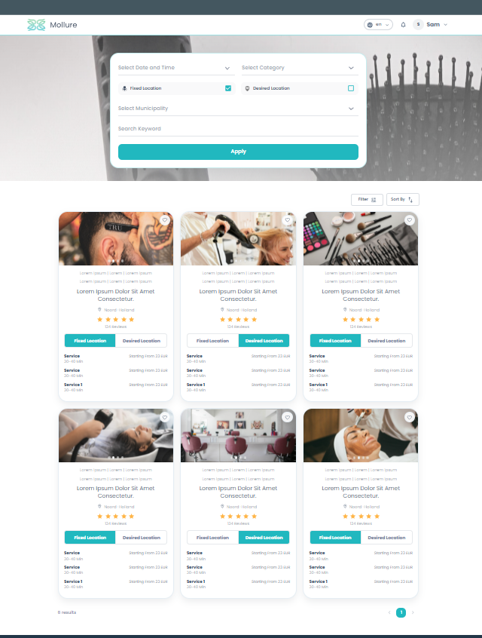
Is page pr buiness_setups ki list a rahi h.
Mujhay aik endpoint chahiye jismay all business setups ki array chahiye or jo jo fields related h oun ko is data sy replace krey or dynamic krdey.i think rating ni h filhal isko static rakhdo

